Word Template for a MEDER 2018 Paper
A. Gasparetto¹ and M. Ceccarelli²
¹ Polytechnic Department of Engineering and Architecture, University of Udine, Udine, Italy, e-mail: alessandro.gasparetto@uniud.it
² University of Cassino and South Latium, Italy, e-mail: ceccarelli@unicas.it

Abstract. The 4th IFToMM Symposium on Mechanism Design for Robotics (MEDER 2018) will be held at University of Udine, Udine, Italy on September 11th - 13th, 2018. The conference will bring together researchers, industry professionals and students from a broad range of disciplines related to mechanisms and robotics to share the latest developments and discuss the directions for the future of mechanisms and robotics research.

Key words: Please indicate four to five keywords, which will also be used for composing the Subject Index (written in 8 pt, justified).
1 Introduction
First page of the manuscript will include at least the title of the paper, name of authors, their affiliation and email addresses, abstract and keywords. The paper should also contain an abstract, an introduction, the main text, conclusions and references.
The manuscript should be written within 8 pages maximum.
Each submission will be rigorously reviewed. Accepted papers will be published in a Proceedings book by Springer.
Author names are written in 10 pt, alignment left. Use author style for automatic formatting. Affiliation of authors is written in 10 pt, Alignment left. Use Affiliation style. Abstract is written in 8 pt, justified. Use abstract style.
The title of the paper should be written in 16 pt bold, Alignment left. Use title style. Section titles are 14 pt bold, alignment left and are subtitle style. Subsection titles are 14 pt bold italic, alignment left and subsubtitle style. The following standard numbering is prescribed: 2, 2.1, 2.2 etc. Instead of simply listing headings of different levels we recommend to let every heading be followed by at least a short passage of text.
The following are some examples of a typical equation, figure, table, citations and references. Please do not change the proposed formatting by introducing other styles or by changing this template.
1.1 Paragraphs and indents
Please note that the first line of text that follows a heading is not indented (first line style), whereas the first lines of all subsequent paragraphs are (normal style). The text is 10 pt, justified. Spacing of the text is 12 pt.
2 Figures
Figures should be centered and referenced in the text as, for example, Fig. 1. The font size in figures should be as normal text (10 pt). Captions are placed under the figure, written in 8.5 pt, using figlegend style. The example follows.
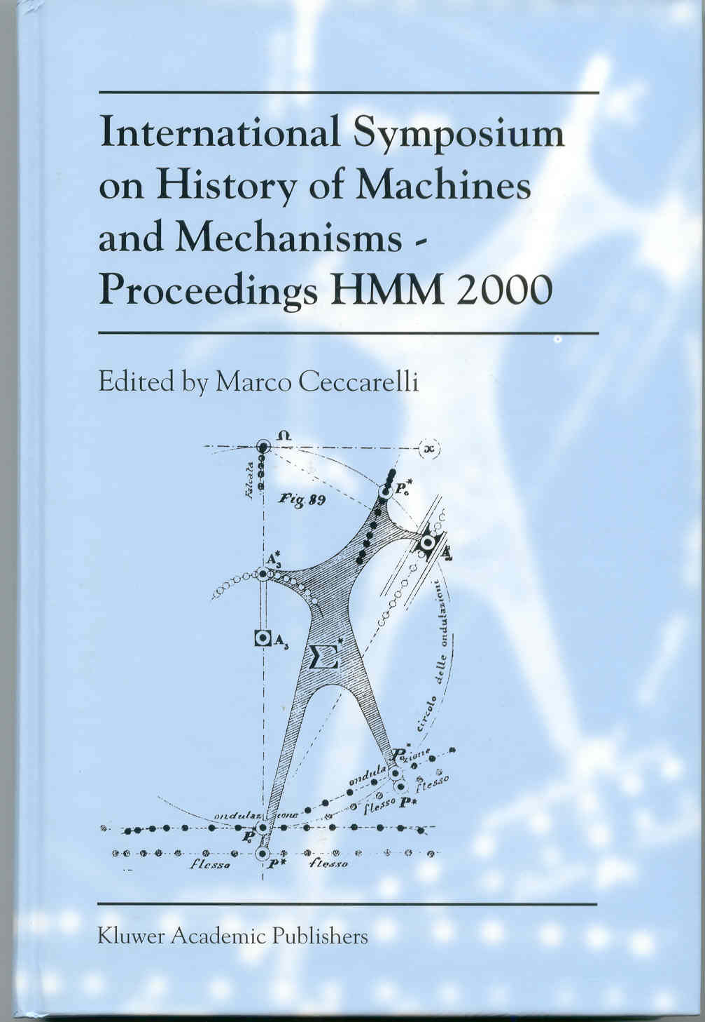
Fig. 1 Please write your figure caption here
3 Equations
The same style as normal text should be used in equation. Here, however Single space is recommended. Equations should be centered and numbered (equation style). They should be referenced in the text as, for instance, Eq. (1). An example of equation is as follows
(1)

4 Tables
Tables should be centered and referenced in the text as Table 1. The font size in tables should be table style (8.5 pt). Captions are placed before the table and are centered (tablelegend style).
Table 1. Please write your table caption here
Description 1 | Description 2 | Description 3 | Description 4
Row 1, Col 1 | Row 1, Col 2 | Row 1, Col 3 | Row 1, Col 4
Row 2, Col 1 | Row 2, Col 2 | Row 2, Col 3 | Row 2, Col 4
Row 3, Col 1 | Row 3, Col 2 | Row 3, Col 3 | Row 3, Col 4
5 Referencing
The reference list should be written in an alphabetical order. A citation in the paper should have the form [1, 3, 2, 4] for a contribution in conference proceedings, journal article, monograph and on line document. Use references style (8.5 pt).
6 Conclusions
Your manuscript must be sent following the instructions and deadlines given in the MEDER 2018web page (meder2018.uniud.it).

Acknowledgments The MEDER 2018 Local Committee wants to acknowledge the support received.
References
1. Ceccarelli, M.: The Challenges for Machine and Mechanism Design at the Beginning of the Third Millennium as Viewed from the Past. In: Proceedings of Brazilian Congress on Mechanical Engineering COBEM2001, Uberlandia, Invited Lecture, pp. 132-151 (2001)
2. Bautista Paz E., Ceccarelli M., Echavarri Otero J., Munoz Sanz, J.J.:A brief illustrated history of machines and mechanisms (Series: History of Machines and Machine Science). Springer (2010)
3. Ceccarelli M., A short account of History of IFToMM and its role in MMS, Mechanism and Machine Theory, Vol. 89, pp.75-91 (2015),
4. Viadero, F. et al..: A model of spur gears supported by ball bearings. In: Computational Methods and Experimental Measurements XIII (CMEM) Invited lecture (2007) Available via WIT eLibrary. http://library.witpress.com/pages/PaperInfo.asp?PaperID=18033
5. Fang Y. and Ceccarelli M., Medium Size Companies of Mechanical Industry in Northern Italy During the Second Half of the 19th Century, in: Essays on the History of Mechanical Engineering, History of Mechanism and Machine Science 31, Springer, Dordrecht, pp.181- 200 (2016).

